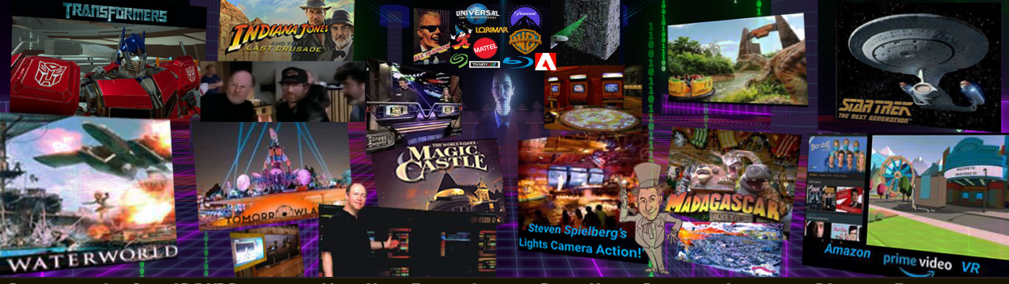
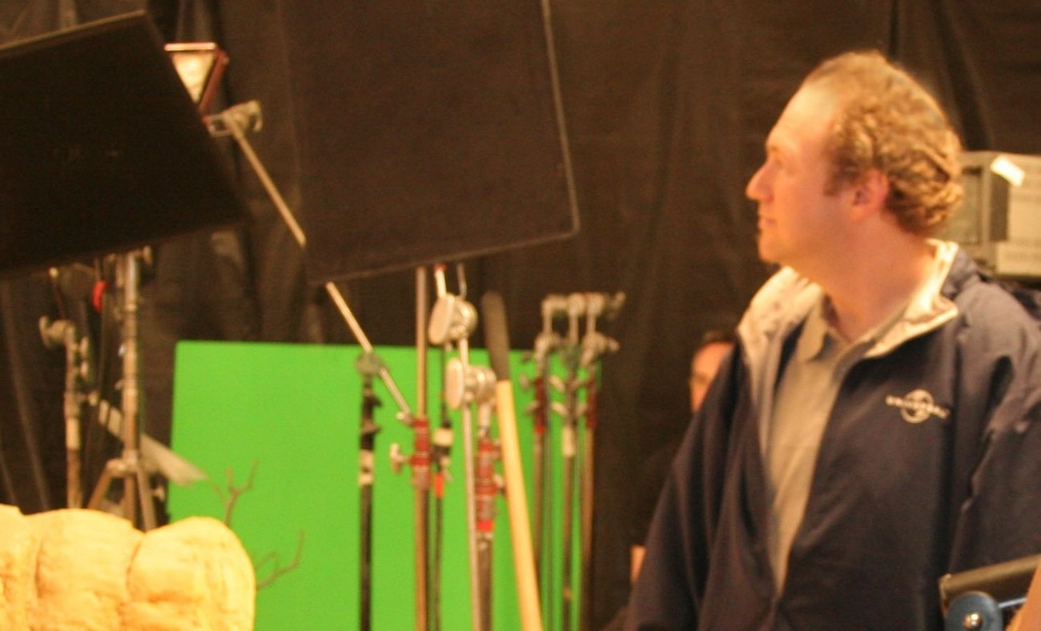  CAREER AT A GLANCE  • 9 Theme Parks  • 6 Museum Galleries  • 100+ Original Musical Works  • 2 Original Musicals  • 1 Published Textbook  • Many Film & TV Productions  • Numerous Home Video Productions  • Numerous Shows  • Numerous Committees & Boards  • Apps • Games • AR • VR • XR  • Industry and Community Recognition  www.HollywoodMagicFactory.com  Harry@transmersive.com | HARRY J. EVRY  Producer • Creative Director • Imagineer • Technical Director • Exhibit & Game Designer • Senior Software Engineer • Author • Composer • Professor  Combining creative technology, storytelling, design, production and engineering to create attractions, exhibits,  apps, games, immersive experiences, films, shows, music and emerging interactive technologies.  PRODUCING • CREATIVE DIRECTION • IMAGINEERING & EXPERIENCE DESIGN  - Technical Producer & Director of Technical Development, Las Vegas Springs Preserve — technical and creative development of dozens of interactive exhibits, games, media experiences and shows throughout the 100+ acre cultural center and nature preserve.  - Senior Technical Designer, Project Design Consultant & IP Owner Representative representing Universal Studios in the development of Resorts World Sentosa’s Universal Studios Singapore.  - Creative Technical Lead on numerous projects and attractions for nine theme parks and additional park concepts, along with dozens of haunts, many exhibits, six museum galleries, and a 100+ acre cultural center and nature preserve.  - Produced early 3D previsualization models and simulations for major transportation, entertainment, aerospace and themed-attraction projects.  MUSIC • FILM & TELEVISION • WRITING & STORYTELLING  - Graphic / Set / FX Design & Art Department Coordinator, Star Trek: The Next Generation.  - Supervised audio, editorial, post-production, titles, VFX, foley and scoring for major television series and feature films.  - Composer, Songwriter, Music Producer, Author & Lyricist — wrote, composed and produced more than 100 original songs and musical works, including soundtracks, two original musicals and 24 songs for the U.S. Department of the Interior’s official America 250 celebration.  - Author, Beginning Game Graphics, Premier Press / Thomson Course Technology.  - Director of Technical Development, Playground Media Group — producing, designing and programming a wide range of interactive Blu-rays, DVDs, games and bonus content for Disney/Pixar, Sony, Mattel, New Line Cinema, ABC and NBC.  MEDIA • APP • GAME • INTERACTIVE & THEMED ENTERTAINMENT TECHNOLOGY  - Post-Production Supervisor & Special Assistant to the President, Lorimar Telepictures & Warner Bros. Television — oversaw post-production, studio upgrades, new production systems and technology innovation initiatives.  - Co-Founder & Chief Technology Officer for multiple interactive-media and AI startups developing technologies for video games, interactive video, karaoke software, video streaming, haptic feedback, audio enhancement, public safety, and cognitive assessment and support.  - Senior Software Engineer, Amazon Prime VR / White Moon Dreams  - Senior Software Engineer & Lead System Integration Engineer, DMG’s Transformers VR.  - Lead Programmer - Seagate VR File Explorer and Media Navigator  - Technical Contributor & Registered Inventor on multiple U.S. patent filings.  - Product Lead and Software and Firmware Engineer, Entech Instruments, PowerMag and Vista Electronics  - Game Designer & Programmer, Tandy/Radio Shack — co-authored and coded pioneering early games and developed the first entertainment simulator.  PROFESSOR • EDUCATION • LEADERSHIP & INNOVATION  - Professor, California Lutheran University (CLU) — Visual Effects, Cinema, App & Game Development, Animation, Motion Graphics, Programming, Imagineering, Themed Entertainment, and Virtual Production  - Lecturer, University of Southern California (USC)  - First Head of Education, VR/AR Association  - Producer, Judge, Board Member & Director of Outreach and Project Approval, California Science & Engineering Fair  - Founded, designed and launched Autodesk’s Plaza de la Raza Digital Media Learning Lab, developing and teaching its initial curriculum  - Developed and taught the first game-development classes offered at a Los Angeles Unified School District high school  - Member & Co-Chair, Media, Decor & Innovation Committees, Academy of Magical Arts and The Magic Castle
  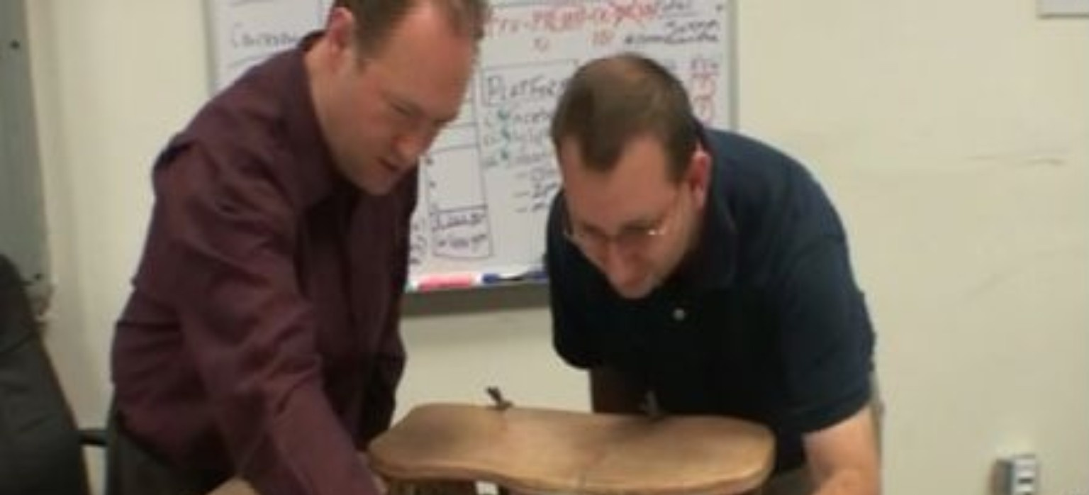
  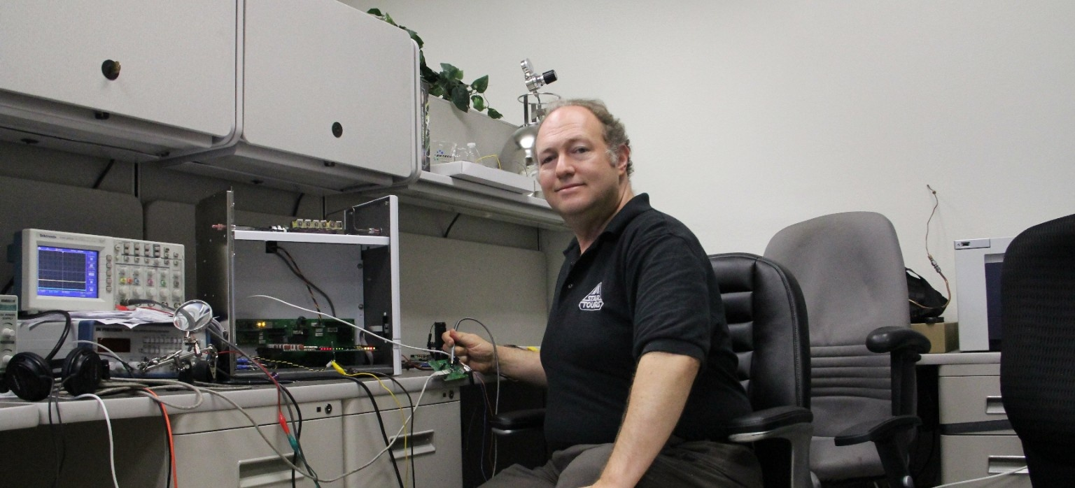
  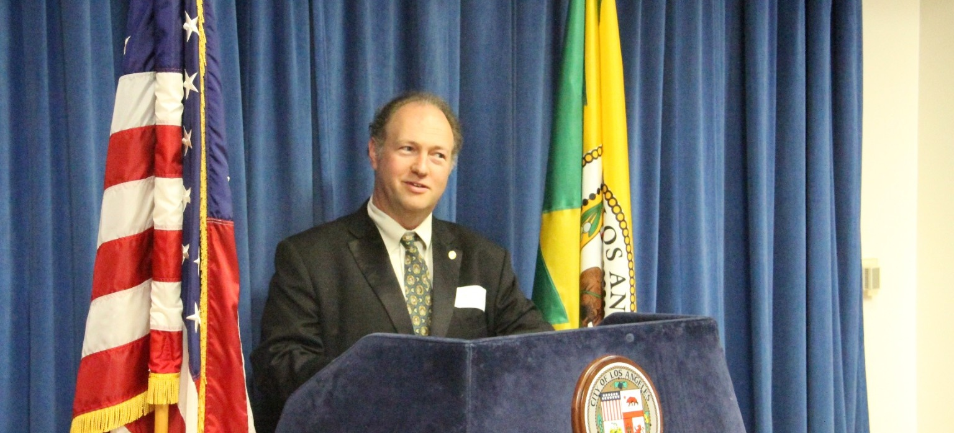
  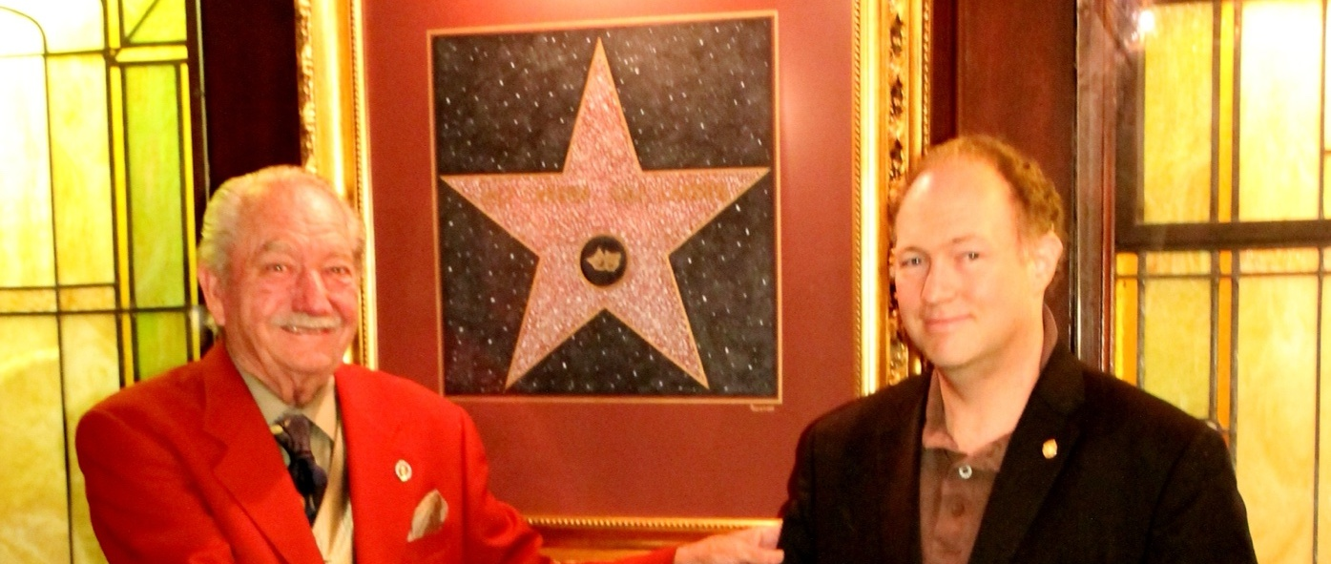

HARRY J. EVRY — SELECTED EXPERIENCE & SUPPORTING DETAIL
SELECTED BRANDS, PROJECTS & ORGANIZATIONS
Amazon • Animal Kingdom • Backdraft • Barbie • A Bug’s Life • California Science Center • California Science & Engineering Fair • California Lutheran University • Disney • Disneyland • Disney California Adventure • Entech • Grab Games • Hasbro • Indiana Jones • Jurassic Park • Las Vegas Springs Preserve • Lorimar Telepictures • Madagascar • Madame Tussauds • Mattel • Microsoft • Nolan Bushnell’s uWink • Paramount Pictures • Resorts World Sentosa • Seagate • SmartSound • Sony • SpectraFX • SpinLaunch • Star Trek • Tandy • Tournament of Roses • Tomorrowland • Transformers • Universal Studios • USC • Walmart Spatialand VR • Warner Bros. • WaterWorld • White Moon Dreams • Academy of Magical Arts and The Magic Castle
INNOVATION & RECOGNITION
- Pioneered and contributed to computer graphics, animation, music and production technologies including network rendering, Blu-ray, online multiplayer gaming, non-linear editing, interactive ride systems, haptic feedback, SMPTE timecode, digital scoring, 4-D theatrical experiences, virtual machine languages, voice synthesis, escape rooms, karaoke software, augmented reality and virtual reality.
- Work recognized by the State of California, City of Thousand Oaks, City and County of Los Angeles, Themed Entertainment Association, CinemaCon, Academy of Motion Picture Arts & Sciences, Television Academy and California Science & Engineering Fair.
- Recipient of two Consumer Electronics Association Innovation Awards and recognition as a Popular Science Invention of the Year.
SOFTWARE, SYSTEMS & TECHNICAL BREADTH
- SmartSound work included Music Maestro and SonicFire Pro, stock-music production libraries, and native QuickTime and DirectX audio subsystems for Adobe Premiere, Matrox and Pinnacle Studio.
- Engineering experience includes laboratory robotics and air analysis, DMX lighting controllers, aircraft flight controls and gauges, game-show systems, interactive audio, VR, system integration and real-time media.
- Teaching and production technologies span C#, C++, Swift, Assembly Language, JavaScript, React, Node.js, Arduino, HLSL, ShaderLab, OpenCV, Unity, Unreal, 3D Studio Max, AutoCAD, Blender, Maya, Houdini, After Effects, Premiere, Nuke, DaVinci Resolve and Fusion.
SELECTED PRODUCTION, FILM & MEDIA CREDITS
- Television and feature work includes ALF, Always, Dallas, Falcon Crest, Full House, The Hogan Family, Indiana Jones and the Last Crusade, Knots Landing, The Last Starfighter, Max Headroom, Max Steel, Midnight Caller, Paradise, Perfect Strangers, Scrooged and Star Trek: The Next Generation and Studio 5B.
- Early 3D previsualization and simulation projects include Amtrak, Cooksey Design Associates, Los Angeles Metrorail, Tomorrowland, Star Trek, SpinLaunch, Magic World and Universal theme park attractions.

